Week 3 Lab Task
Name: Faseeha Siddiqui
Scanning & Enumeration
NIAI NAVTTC — Certified Ethical Hacker (CEH) Course
⚠ Important: All tasks must be performed only in your isolated virtual lab environment. Never test on real networks or systems without explicit written permission.

Task: Conduct a comprehensive network scan to identify all active hosts and services. Perform vulnerability scanning on identified hosts. Perform active enumeration on a Windows-based network to identify Active Directory users, groups, and systems.

Step 1 — Set Up Your Target VM
▶ Download and Import Metasploitable 2
Go to: sourceforge.net/projects/metasploitable/
Download the Metasploitable 2 zip file and extract it.
In VirtualBox: File → Import Appliance, or just add the .vmdk as a new VM.
Set BOTH Kali and Metasploitable to the same 'Host-Only Adapter' network so they can talk to each other.
Start Metasploitable. Login: msfadmin / msfadmin
Run ifconfig to find its IP address (e.g. 192.168.56.101). Note this IP — you will use it in all commands below.

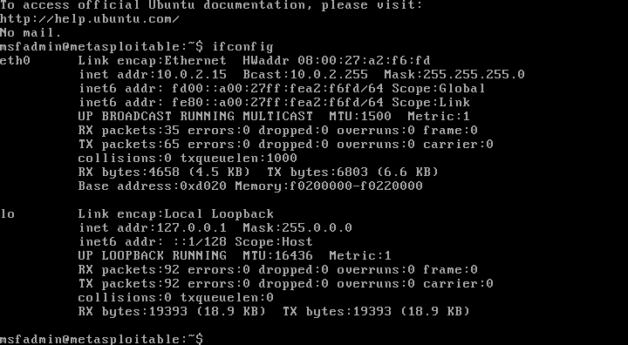
Step 2 — Network Scanning with Nmap
▶ Ping Sweep — Find Live Hosts
nmap -sn 192.168.56.0/24
This lists all devices that are online on your host-only network.
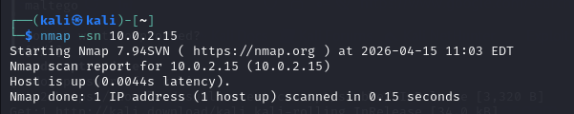
▶ Full Port Scan with Service Detection
nmap -sV -p- 192.168.56.101
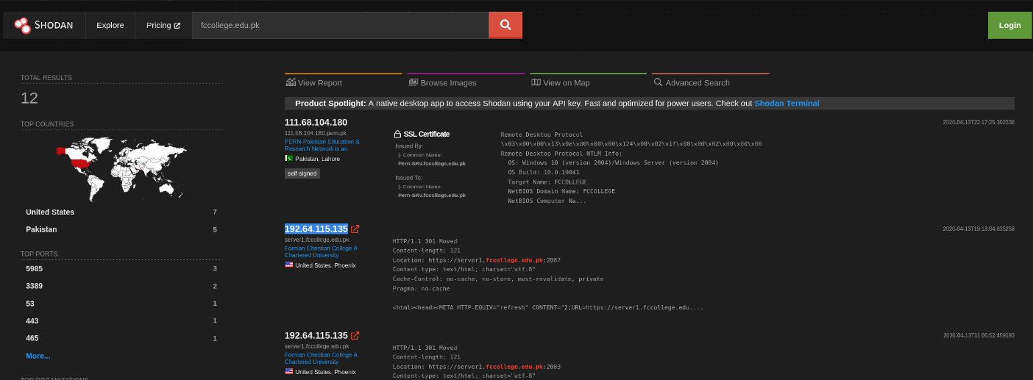
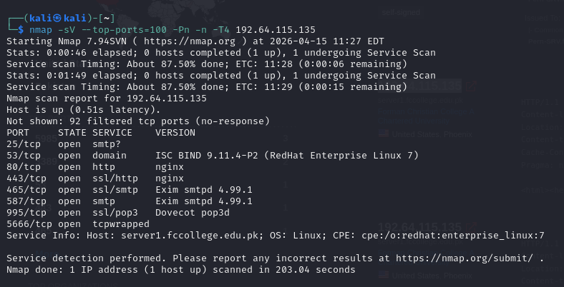
-sV detects service versions. -p- scans all 65535 ports.
▶ OS Detection
nmap -O 192.168.56.101
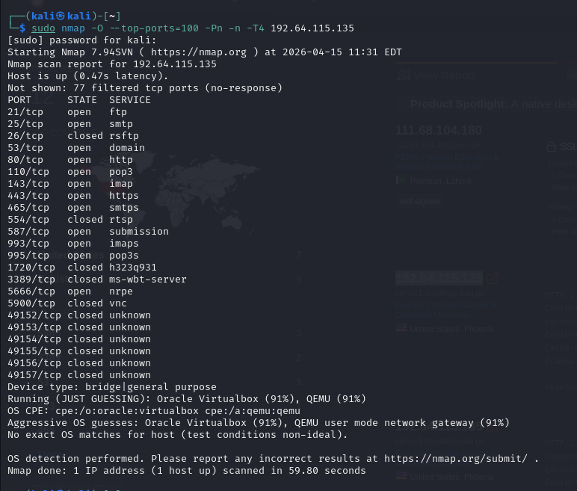
▶ Vulnerability Scan with Nmap Scripts
nmap --script vuln 192.168.56.101
This runs Nmap's built-in vulnerability detection scripts against the target.
Step 3 — Enumeration
▶ Enumerate Windows / Active Directory (if Windows VM is available)
enum4linux -a 192.168.56.101
This tool extracts users, groups, shares, and policies from Windows/Samba targets.
▶ SMB Enumeration
nmap --script smb-enum-users 192.168.56.101
nmap --script smb-enum-shares 192.168.56.101
▶ Additional Enumeration with Nmap Scripts
nmap --script=nbstat 192.168.56.101 # NetBIOS info
nmap --script=snmp-info 192.168.56.101 # SNMP info
nmap --script=dns-brute 192.168.56.101 # DNS brute force
Step 4 — Document Your Findings
▶ Write a Scan Report
Record the following for each host found:
- IP address and hostname
ANS: IP Address: 142.171.183.227
Hostname: tesla.com
- Open ports and services running
ANS: HTTPS(443)
HTTP(80)
- Operating system detected
ANS: No exact OS matches for host
- Any vulnerabilities flagged by Nmap
ANS: Diffie hellman key exchange – man in the middle

- Any users/shares found during enumeration
ANS: NO SMB shares found hence no user enumeration

🎯 Goal: A complete scan report listing active hosts, open ports, running services, OS info, and enumerated users/shares — with potential vulnerabilities identified.

